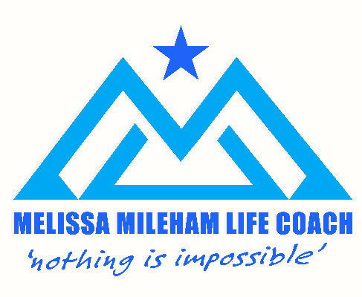

Privacy Policy:
This Privacy Notice provides an overview of the processing of your personal data in the context of the use of this website and details that you provide prior to and during your coaching sessions.
Furthermore, this Privacy Policy informs you about your rights and the possibilities you have to control your personal data and to protect your privacy.
I take the protection of your personal data very seriously and continually take appropriate measures to protect your data from unauthorised or unlawful processing and against accidental loss, destruction or damage.
Details of the controller: I am the only person that ever sees your data, it is strictly confidential to all others.
Melissa Mileham, Hatfield, Herts, AL10 8AJ.
Types of data I collect: The only data I collect from the website are your name, email address and telephone number should you send me a message and wish me to contact you. I do not analyse the website for any visitor traffic and details nor are you required to enter a password or any details to use the website.
The only data I collect are as follows:
Name
Gender (optional)
Contact details: Name, telephone number, email, address and date of birth (if relevant)
Initially there are a couple of questionnaires to complete but these only serve to provide me with further information to understand how life coaching can benefit you. The questionnaires are optional.
I also take brief notes during our sessions and will make some more comprehensive notes immediately after the session has ended, this ensures I serve you to the best of my ability and am clear on the details on your situation and your goals for example.
Data transmission: I do not share your data with anyone at any point. It is kept confidentially in a filing cabinet in a secure room.
How long will your data be stored? Legally due to the nature of our work your data has to be kept for 7 years after your last session, in the case of children this is 7 years after they reach the age of 18.
Information on the voluntary nature of the information provided: You are not legally obliged to provide me with any data however due to the nature of the work the transmission of the more basic data is a basic requirement for the contractual process between us.
I do ask, that prior to working together that you sign a GDPR statement to confirm that you understand the Privacy Policy and the contractual relationship that you are entering in to regarding your data.
Website provider: The website is hosted by Ionos.co.uk. Ionos.co.uk provides me with the online platform that allows me to promote my services.
Amendment of the Privacy Policy: I reserve the right to update the Privacy Policy at any point, the updated version will always be the latest version on the website.
Accessing your details: If you would like to access or amend your details in any way please feel free to do so at any time by contacting me on the email address below.

E: melissa@melissamilehamlifecoach.co.uk
W: melissamilehamlifecoach.co.uk T: 07979 756528

